ANALOG CIRCUIT DESIGN

PROJECT

**TOPIC: DESIGN OF 2 STAGE**

**OPERATIONAL AMPLIFIER**

A.ANIRUDH SIMHA(PES1UG21EC001)

ACHYUTH.S.S(PES1UG21EC010)

AKASH RAVI BHAT(PEES1UG21EC001)

**AIM:** Design of a two-stage operational amplifier with Miller compensation technique.

**CIRCUIT DIAGRAM:**

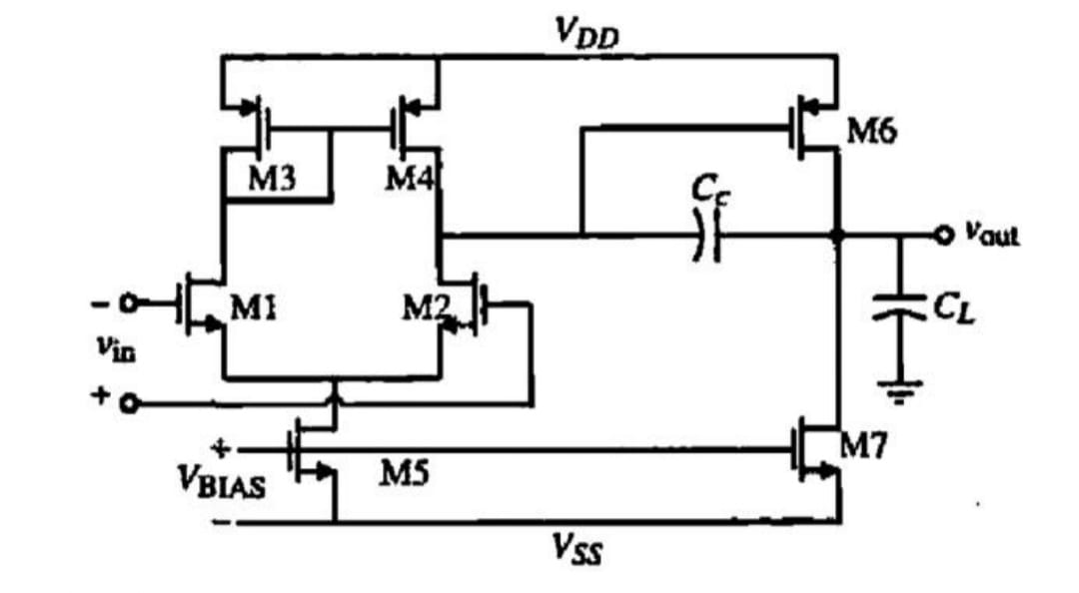

**DESIGN:**

The design consist of an NMOS differential amplifier with active load as the first stage follow by a PMOS common source amplifier as the second stage. A compensation capacitor is connected between the output of the second stage and the output of the first stage to obtained pole splitting and hence op-amp compensation. Figure shows the schematic implemented for the direct feedback two-stage op-amp design.

Required Design Specifications

Parameter Value DC

Gain 70 Db

GBW 20 MHz

Phase Margin ≥ 60°

𝑽𝑫𝑫 1.8 V

𝑪𝑳𝒐𝒂𝒅 2 𝑝𝐹

Power ≤ 300 𝜇W

Transistor Sizing

Transistor Aspect Ratio ( W/𝑳 )

M1, M2 6

M3, M4 14

M5 12

M6 173

M7 75

**THEORY:**

CMOS operational amplifiers are one of the most fundamental, versatile and integral building blocks of many analog and mixed-signal circuits and system. They are used in a wide range of applications such as comparators, differentiators, dc bias applications and many other applications.As a result, single stage operational amplifiers have been preferred for their stable frequency response. However, CMOS technology has been constantly scaling down establishing some challenges when designing operational amplifiers and others integrated circuits.

Therefore, alternative architectures must be implemented to overcome the drawback of single stage amplifiers. Multiple stage amplifiers can be implemented to achieve higher gains circuit designs regardless of the limitations of the power supply voltage and other performance aspects that affect single stage amplifiers.Two-stage operational amplifiers are the most common used multistage amplifier because it can provide high gain and high output swing. However, an uncompensated two-stage operational amplifier has a two-pole transfer function, and these are located below the unity gain frequency. Therefore, a frequency compensation circuity must be implemented to ensure stability.

Miller Compensation Technique Principles

The Miller effect makes one pole more dominant by moving the pole down in frequency, while the other becomes less dominant by moving the pole up in frequency (pole splitting). This action is intended to achieve adequate phase margin by forcing the system transfer function to behave like a single pole system. The Miller compensation technique consists Page 12 of 25 on a compensation capacitor placed between the output of the first stage (differential amplifier) and the output of the operational amplifier (output of the gain stage amplifier).

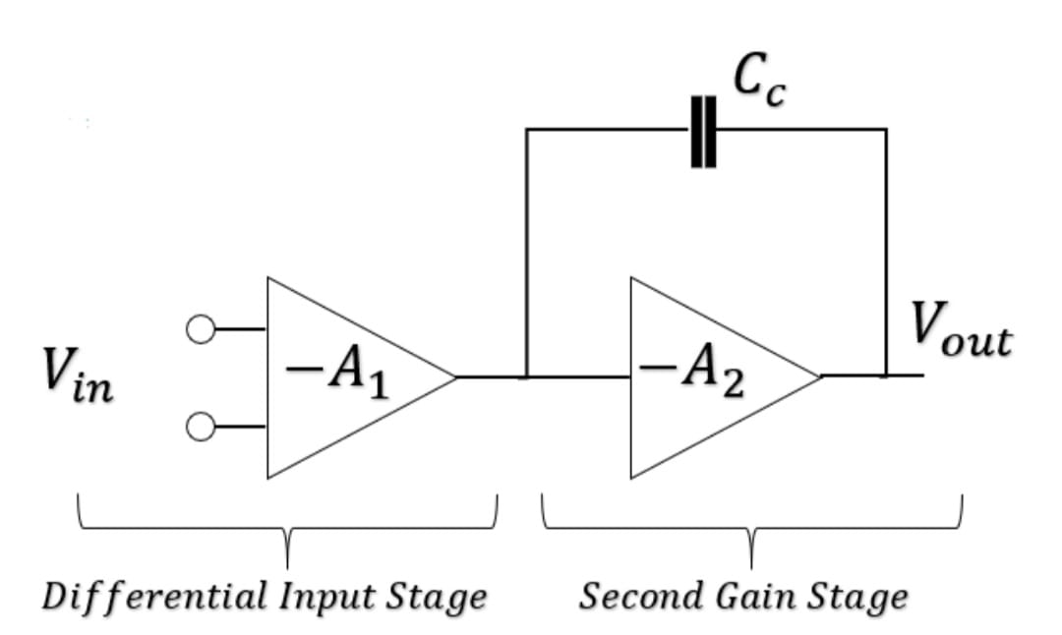

**CIRCUIT DIAGRAM:**

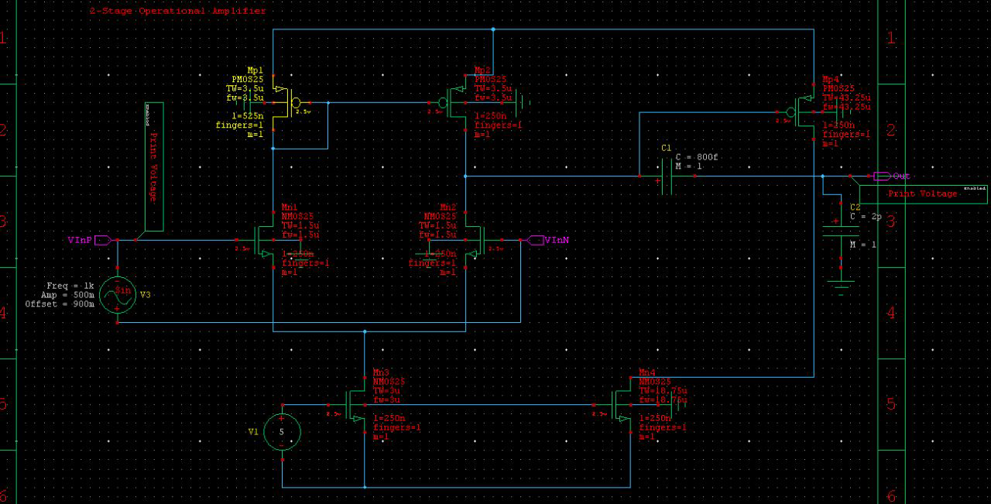

**INPUT AND OUTPUT WAVEFORMS:**

CALCULATION OF Vin p-p

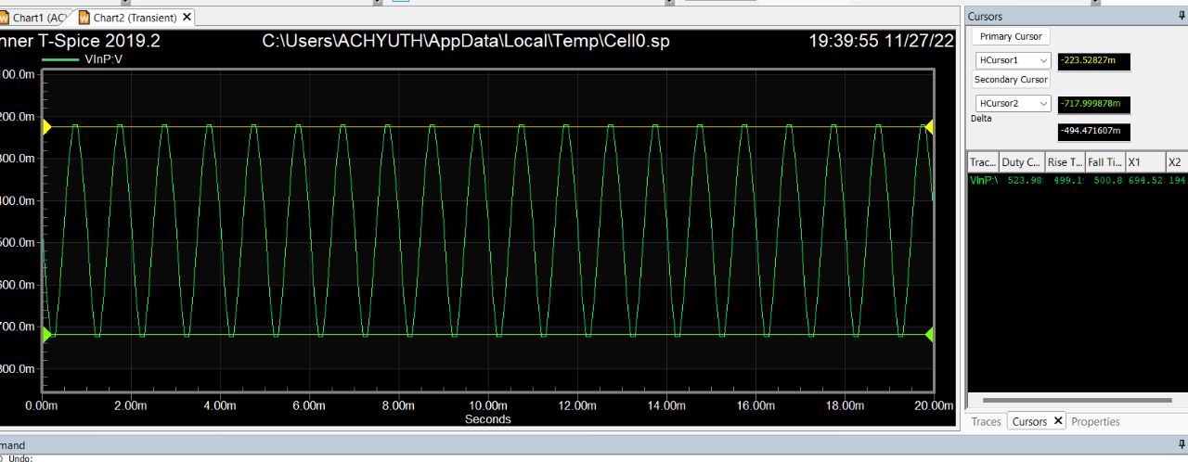

CALCULATION OF Vout p-p

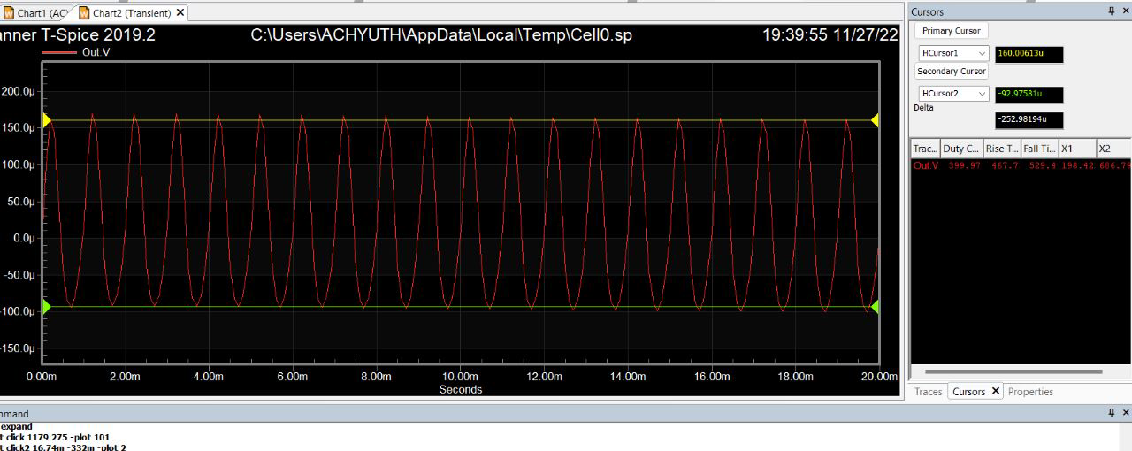

**CALCULATION OF GAIN:**

For calculating the gain we use the formula Av=20log(Vout/Vin)

Here Vout=-252.98u

Vin=-497.49m

Hence Av= 65.68dB

**EXPECTED VALUE OF THE GAIN:**

Av=70dB